COURSE CODE/TITLE: | CPE 010 |  | SECTION: | CPE21S3
DATE PERFORMED: | 7/11/26 |  | DATE SUBMITTED: | 7/13/26
NAME: | Ralf Nicolo B. Abello |  | INSTRUCTOR: | Engr. Jimlord Quejado

ACTIVITY NO. 1.1 | Algorithm, Flowchart, Pseudocode
1. PROCEDURE OUTPUT
ILO A:
Sections | Answers
Header File Declaration Section | 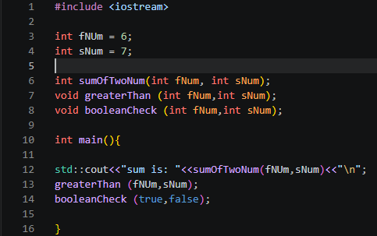
Global Declaration Section
Class Declaration and
Method Definition Section
Main Function
Method Definition | 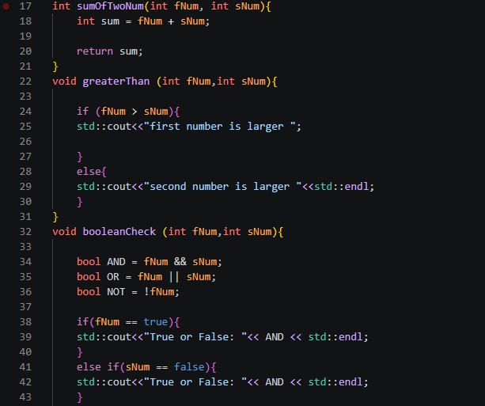  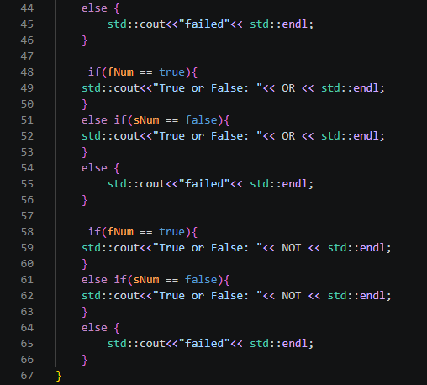

Code analysis:
This code declares fNUm and sNum as global variables initialized to 6 and 7, and defines three functions, sumOfTwoNum, greaterThan, and booleanCheck, that are called from main. In sumOfTwoNum, the parameters fNum and sNum are added together into a local variable sum, which is returned and printed alongside the string "sum is: ". The greaterThan function compares fNum and sNum using an if-else statement, printing "first number is larger" if fNum is greater, or "second number is larger" otherwise; note that because the local parameters are also named fNum and sNum, they shadow the global variables of the same name, so the functions operate on whatever values are passed in as arguments rather than the globals directly. The booleanCheck function is called with true and false instead of the global variables, and inside it computes three boolean values, AND using the logical AND of fNum and sNum, OR using the logical OR, and NOT using the negation of fNum, then runs each through an identical if-else structure that checks whether fNum equals true or sNum equals false before printing the result, falling into a "failed" branch only if neither condition is met.
Table 1-1. C++ Structure Code for Answer

ILO B:
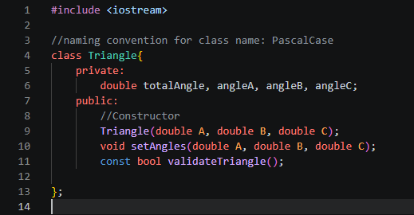
This code declares a Triangle class with four private double members, totalAngle, angleA, angleB, and angleC, to hold the triangle's angle data, along with a public constructor Triangle(double A, double B, double C), a setAngles method, and a const validateTriangle method for checking the angles. Only the declarations are shown here, so the actual logic for these three methods would need to be defined separately outside the class.

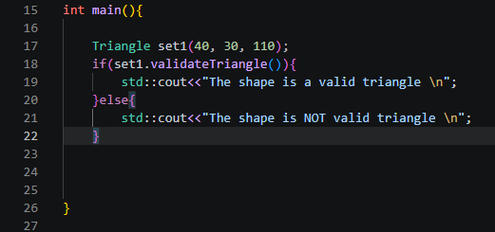
This code creates a Triangle object named set1 with angles 40, 30, and 110, then calls validateTriangle() on it to check whether those angles form a valid triangle. Since the angles sum to exactly 180, the if-else statement should print "The shape is a valid triangle" to the console.
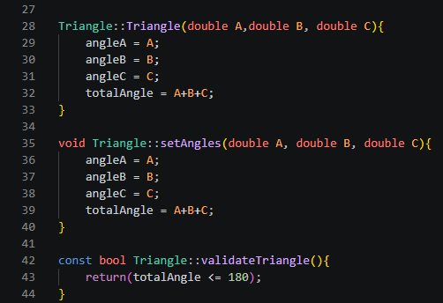
This code defines the constructor and two methods for the Triangle class. The constructor Triangle::Triangle(double A, double B, double C) assigns the parameters A, B, and C to the member variables angleA, angleB, and angleC, and also sums them into totalAngle, initializing a new triangle object with its angle data set. The setAngles method does the exact same assignment logic, letting me update angleA, angleB, angleC, and totalAngle on an existing object without creating a new one. Finally, validateTriangle checks whether totalAngle is 180 or less, returning true if the angles could form a valid triangle and false otherwise.

Output:
Table 1-2. ILO B output observations and comments.

2. ANSWERS TO SUPPLEMENTAL ACTIVITY
Task 1:
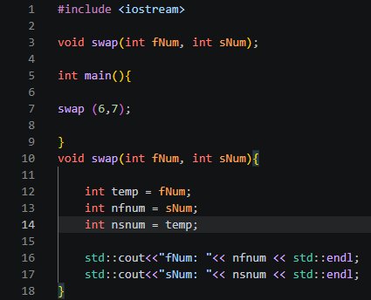

Output:

Code analysis:
This code swaps two numbers using a temporary variable. The swap function takes fNum and sNum as parameters, then stores fNum in temp to preserve its value before it gets overwritten. It assigns fNum's original value (held in temp) to nfnum, and sNum's value to nsnum, effectively reversing the two values into new variables. The swap works correctly because temp holds onto the original fNum before any reassignment happens, preventing the data loss that would occur if the values were swapped directly without a holding variable. Finally, the function prints nfnum and nsnum, showing that the values have been exchanged, nfnum now holds what was originally sNum (7), and nsnum holds what was originally fNum (6). This is a basic three-variable swap algorithm, a fundamental technique used when two values need to be exchanged without a built-in swap function.

Task 2:
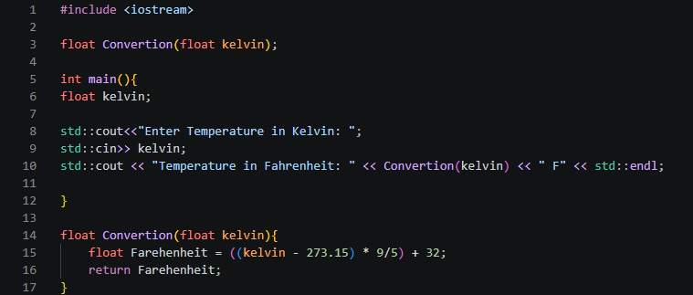

Output:

Code analysis:
This code converts a temperature from Kelvin to Fahrenheit. The main function prompts the user to enter a value, stores it in kelvin, and passes it to the Convertion function. Inside Convertion, the parameter kelvin is used to calculate Farehenheit by first subtracting 273.15 to convert Kelvin to Celsius, then multiplying by 9/5 and adding 32 to complete the Celsius-to-Fahrenheit formula. The result stored in Farehenheit is returned to main, where it's printed alongside the original kelvin input. This program demonstrates a simple unit conversion using a single formula-driven function, taking one input value and transforming it through a mathematical expression before returning the final result for display.

Task 3:
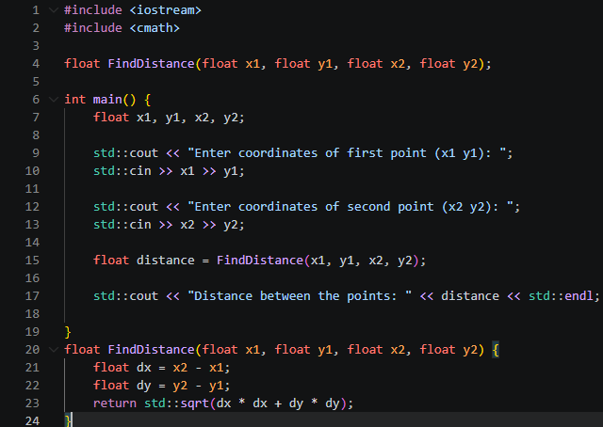

Output:
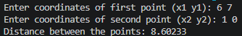

Code analysis:
This code calculates the distance between two points using the distance formula. In main, the user enters two sets of coordinates, x1, y1 for the first point and x2, y2 for the second, which are passed into the FindDistance function along with the result stored in distance. Inside FindDistance, dx is calculated as the difference between x2 and x1, and dy as the difference between y2 and y1, representing the horizontal and vertical distance between the two points. These differences are then squared, summed, and passed through std::sqrt to apply the Pythagorean theorem, producing the straight-line distance between the points. The final result is returned to main and printed alongside distance, giving the user the calculated distance based on their input coordinates. This program demonstrates how a mathematical formula can be implemented directly in code, using parameters to carry coordinate values through a calculation and back to the caller.

Task 4:
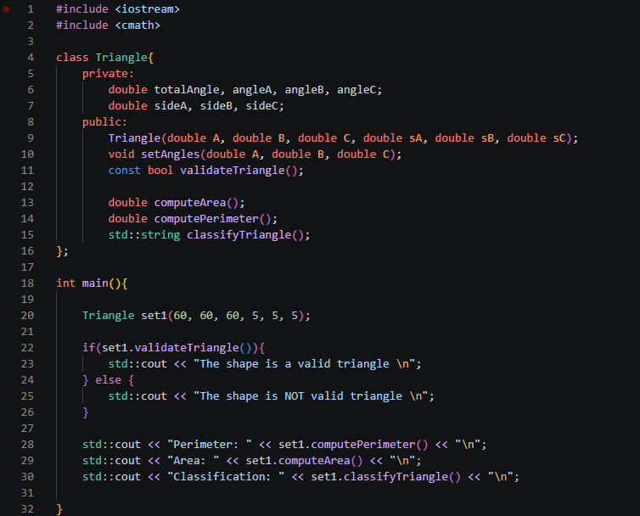
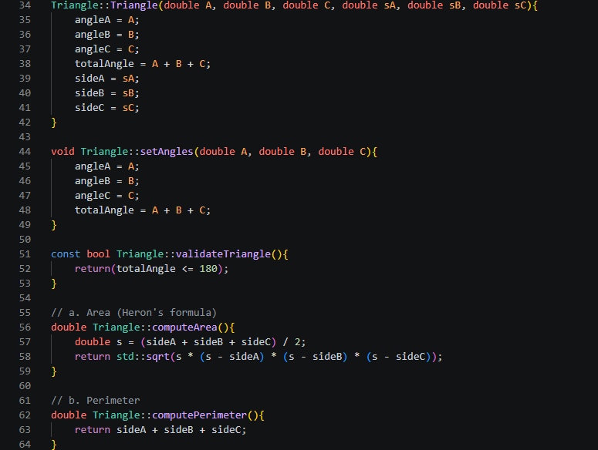
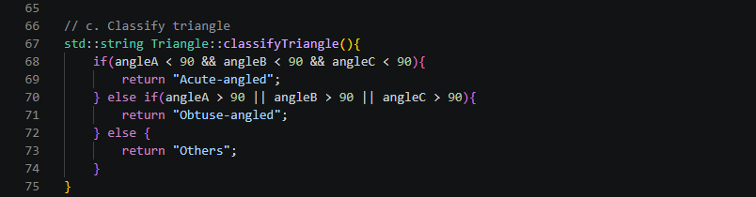

Output:
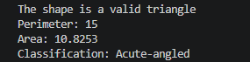
Code analysis:
This code defines a Triangle class that lets me validate a triangle's angles and compute its area, perimeter, and classification all through one object. I built the constructor to take six parameters, A, B, C for the angles and sA, sB, sC for the sides, and store them directly into the private members angleA, angleB, angleC, sideA, sideB, sideC, while also summing the angles into totalAngle so I don't have to recalculate it every time I need to validate the shape. I set up validateTriangle to check whether totalAngle is 180 or less, which is how I confirm the angles I passed in actually form a real triangle before doing anything else with the object.

For the calculations, I used Heron's formula in computeArea, finding the semi-perimeter s from sideA, sideB, and sideC first, then passing it through std::sqrt to get the area, while computePerimeter just adds the three sides together directly. I also wrote classifyTriangle to compare angleA, angleB, and angleC against 90 degrees so I can tell whether my triangle is acute or obtuse, though I noticed my "Others" case only really catches right triangles or ones that technically failed my earlier validation check. Testing this with my set1 object (60, 60, 60, 5, 5, 5) gives me an equilateral triangle, which is a good check since I know the area, perimeter, and classification I should expect going in.

Conclusion:
This activity helped me get a firmer grip on C++ program structure by working through both plain functions and classes. In ILO A, I practiced writing functions that handled sums, comparisons, and boolean logic, which made me pay closer attention to how parameters and scope work, especially after running into variable shadowing with fNum and sNum. In ILO B and the supplemental tasks, I applied that same thinking to building the Triangle class, where I got to see encapsulation in action while implementing real formulas like Heron's formula and the distance formula myself. Overall, this activity made the connection between algorithm design, pseudocode, flowcharting, and actual working code a lot clearer to me, and gave me a better sense of when a simple function is enough versus when a class is the better tool for the job.

3. ARTIFICIAL INTELLIGENCE (AI) USE DISCLOSURE STATEMENT
I hereby declare that artificial intelligence (AI) tools were used, if applicable, in the preparation of this academic work. The following indicates the nature and extent of AI assistance:

Tools Used: | ChatGPT & Grammarly
Examples: ChatGPT, Microsoft Copilot, Grammarly, QuillBot, etc.

Purpose of Use: | Grammar Correction
Examples: grammar correction, idea generation, formatting, summarization, code assistance, explanation of concepts, etc.

Extent of Use:
Explain how AI was used and confirm that it did not replace original thinking, analysis, authorship, or completion of the required work.

By submitting this activity, I affirm that my use of AI complies with T.I.P.’s AI usage policy and does not exceed the permitted limits for similarity, automated content generation, or academic assistance.

I understand that any false, incomplete, or misleading disclosure may be subject to investigation in accordance with due process and may result in sanctions for violation of existing T.I.P. policies.

Lab activities, templates, and related instructional materials shall not be reuploaded, reproduced, distributed, or shared with external organizations or third parties without the prior express written permission of the Technological Institute of the Philippines.

